Phase 5: Project Development Phase
Set up the complete development environment required for Pocket Smart AI.
Install and configure Python, Fast API, required libraries, and supporting tools.
Configure the Gemini API and securely store API credentials using environment variables.
Develop the backend using a modular Fast API architecture.
Create separate modules for authentication, AI processing, recommendations, and user sessions.
Develop the Home Interior Planner to accept:
Total budget
Room type
Required products
Quantity
Style preferences
Develop the Party Budget Planner to accept:
Total budget
Number of guests
Event type
Venue requirements
Food requirements
Decoration requirements
Develop the Jewelry Budget Planner to accept:
Budget
Occasion
Jewelry style
Color preferences
Optional outfit image
Integra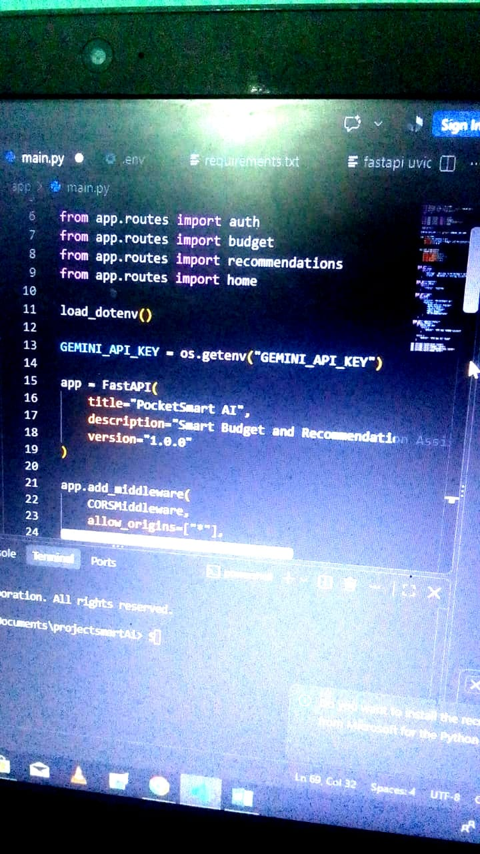te Gemini AI with the planner modules.

